**Project-V: An Automated Community Portal:** Business in the 21st Century is above all BUSY. Distractions are everywhere. The current crop of “enterprise intranet portals” is often high noise and low value, despite the large capital expenditures it takes to stand them up. Email takes up 30 - 70% of an employee’s time. Chat and Instant Messaging are either in the enterprise or just around the corner. Meanwhile, management is tasked with unforeseen and unfunded leadership and change-agent roles as well as leadership development and succession management. What is needed is a simplified, repeatable process that enhances communications within an enterprise, while allowing management and peers to self-select future leaders and easily dynamically recognize high-performance team members. Additionally, the system should function as a general-purpose content management, business intelligence, and peer-review application. Glasscode’s goal is to build that system.

**Usecase diagram:**

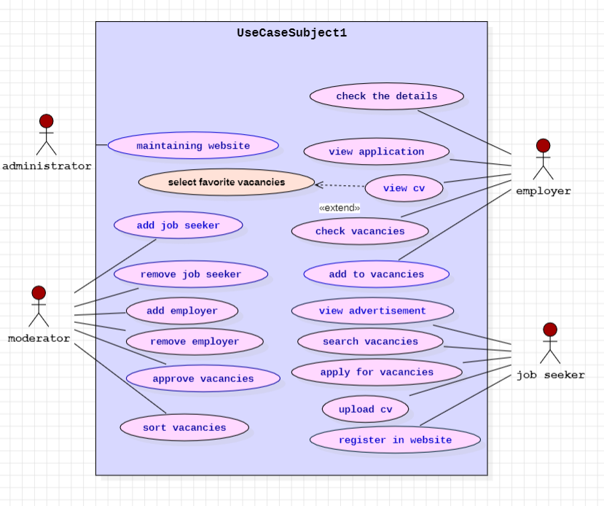

**Activity Diagram:** job provider activity

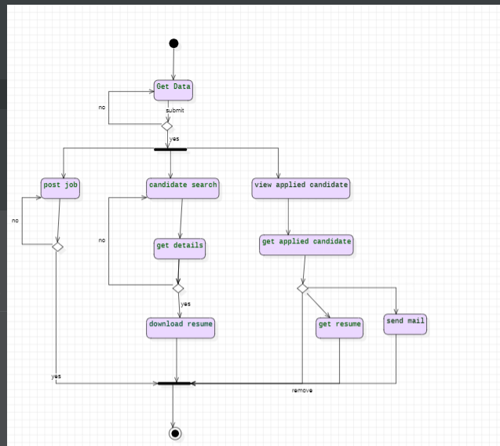

Admin activity:

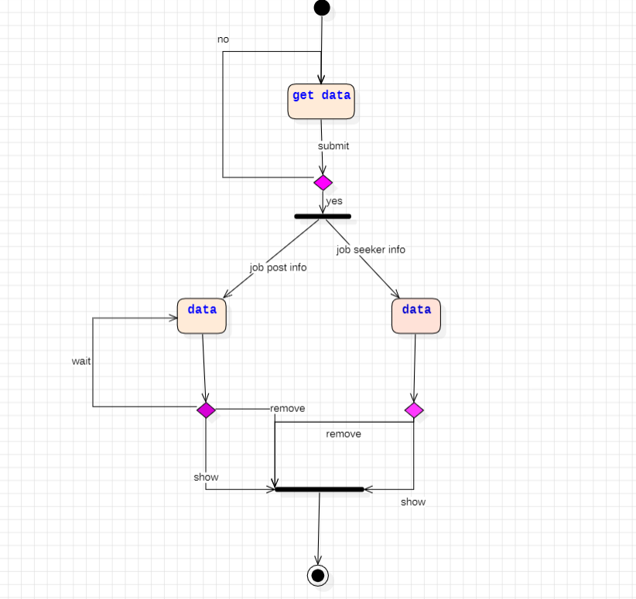**Statechart:**

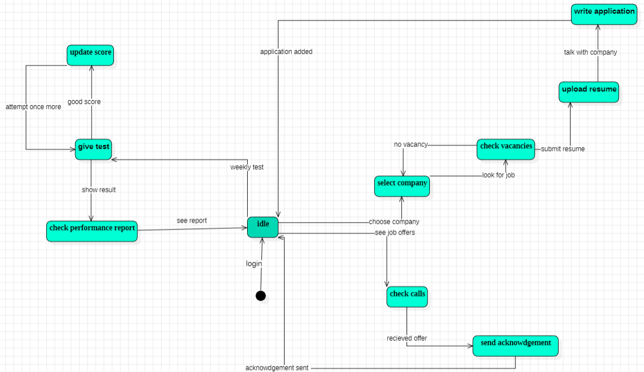

**Class diagram:**

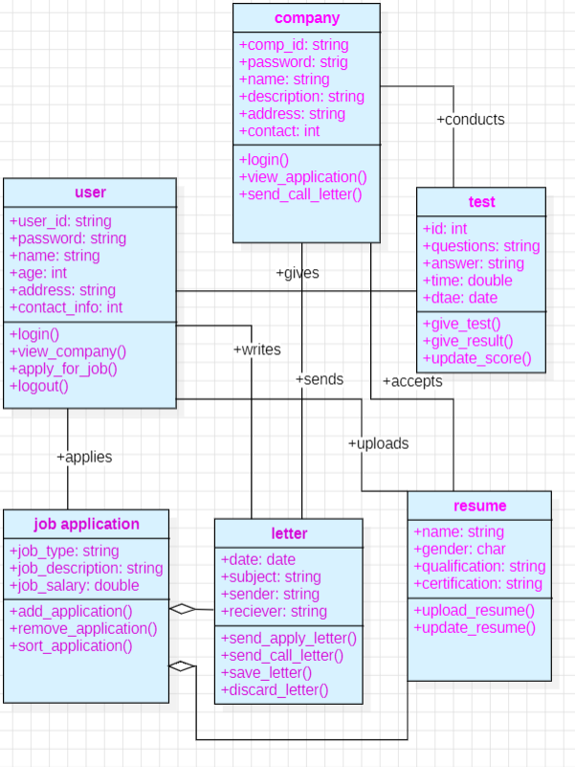

**Sequence diagram:**

